

User Guide

LTC Reportables
Facility User Guide

Version 1.0

1- Click on the Survey Link in the Email Invitation you received -The below page will open up
Dear Long-Term Care Facility,

Reportable Event submissions to NJ DOH HFS&FO have been transitioned to the NoviSurvey platform. The Hippocrates system URL you previously used for this purpose is no longer available.

Please bookmark the below NoviSurvey link to use for all your reportable event submissions going forward. This link will direct you to the NoviSurvey reportable events survey. You will no longer need to provide a facility specific id / key code to access and submit your reportable events. The survey content however remains the same.

Directions for using the new NoviSurvey platform to submit Reportables is attached. Please download and save this document for your future reference. Should you have any questions or issues, please contact the NJ DOH Acute Care Team at LTC-Reportables@doh.nj.gov .

Thank you!
NJ DOH HFS&FO
[SurveyLink]

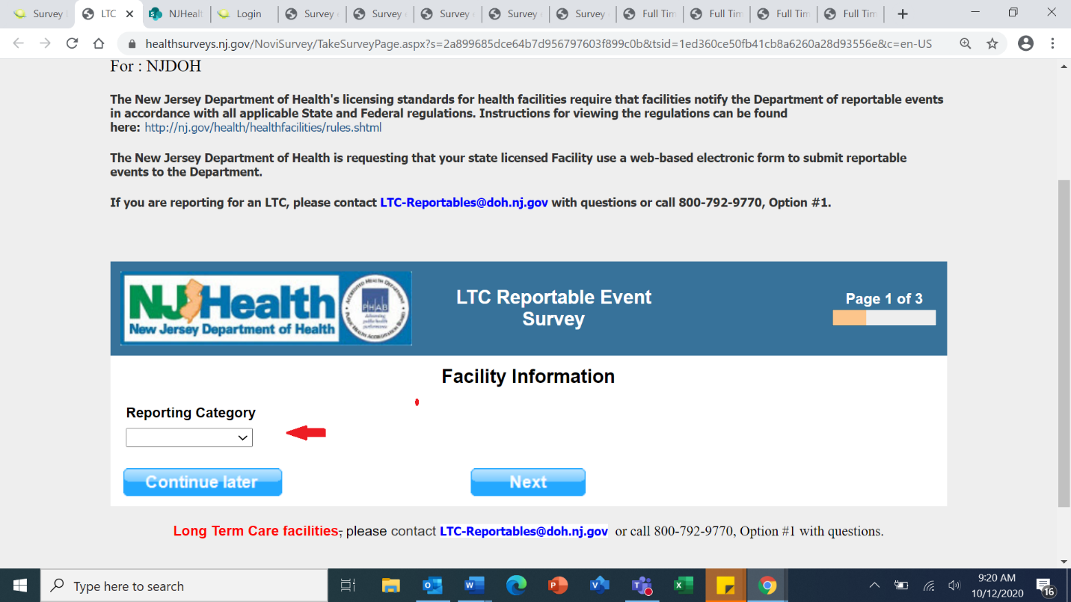
2- Choose the program area from the “Reporting category” drop down list and click NEXT

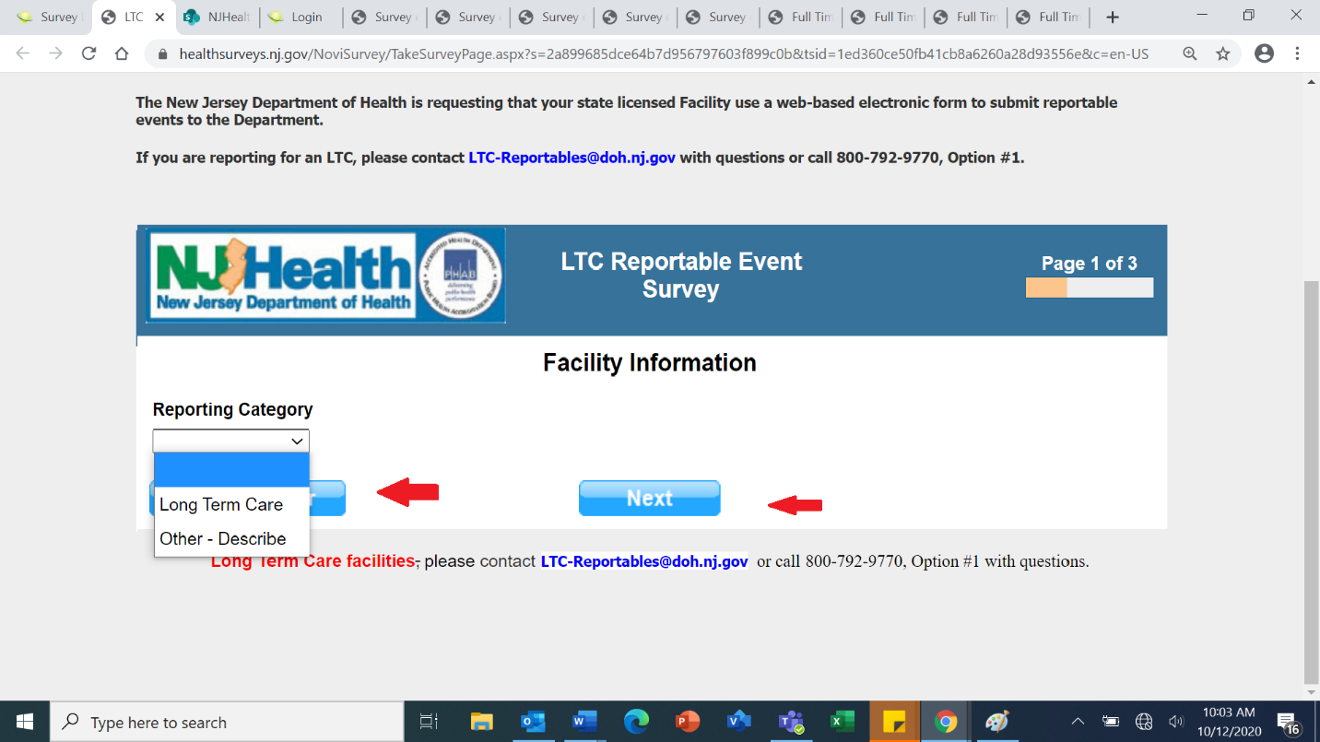

3- Provide details on the Facility Information depending on the reporting category selected and click NEXT

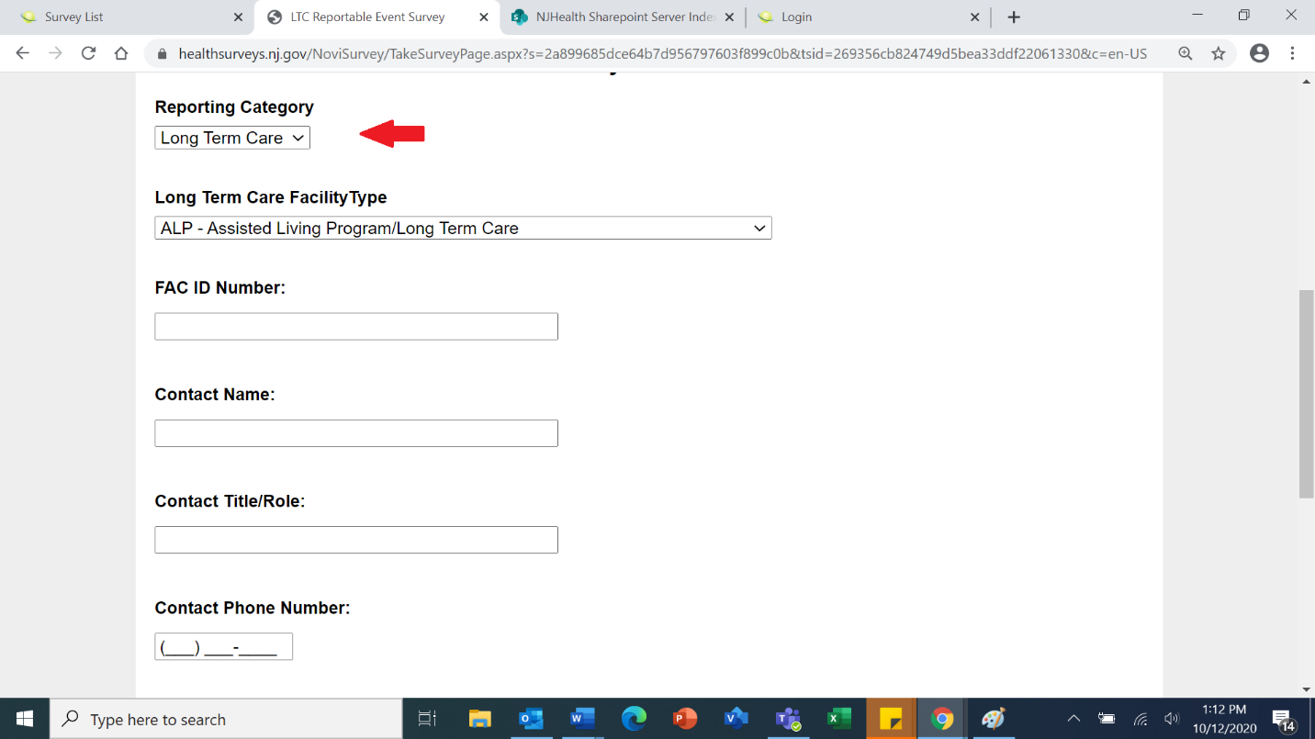

4- Choose the Type of Event you are reporting and click NEXT

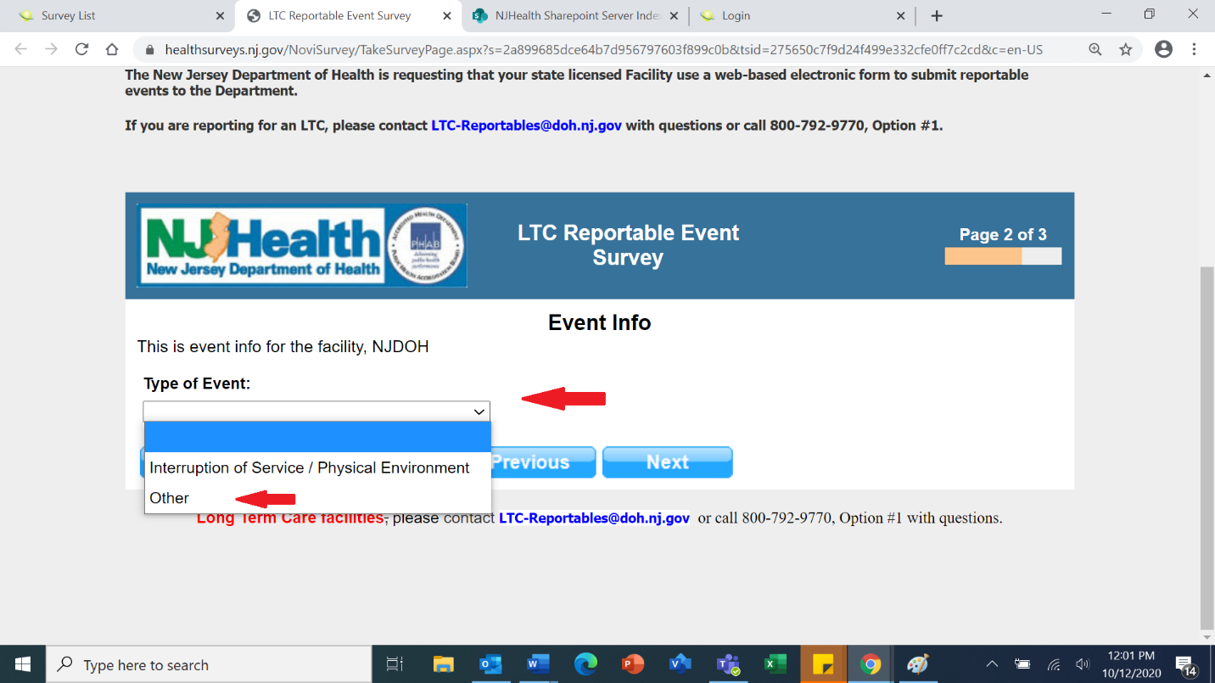

5- If the Type of Event is “Other”, complete the AAS-45 form information and click NEXT

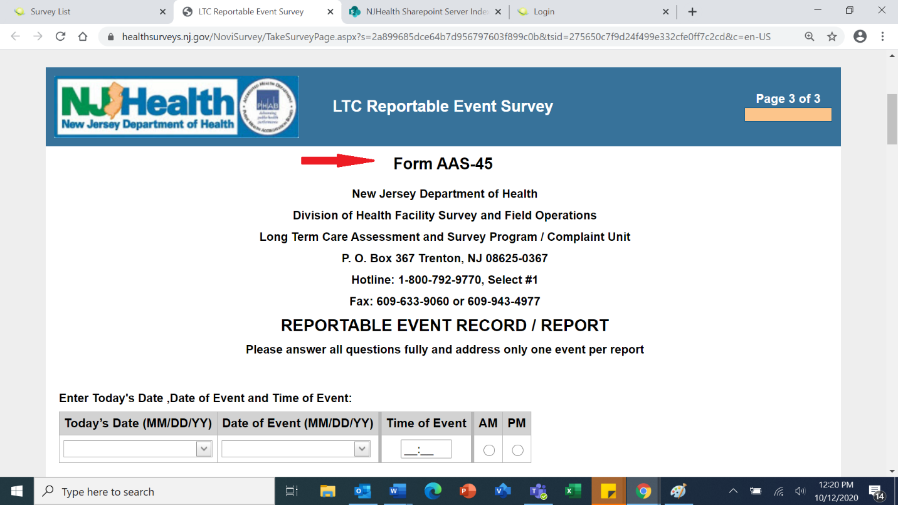

6- The below message will be displayed to confirm your reportable event Survey has been submitted.

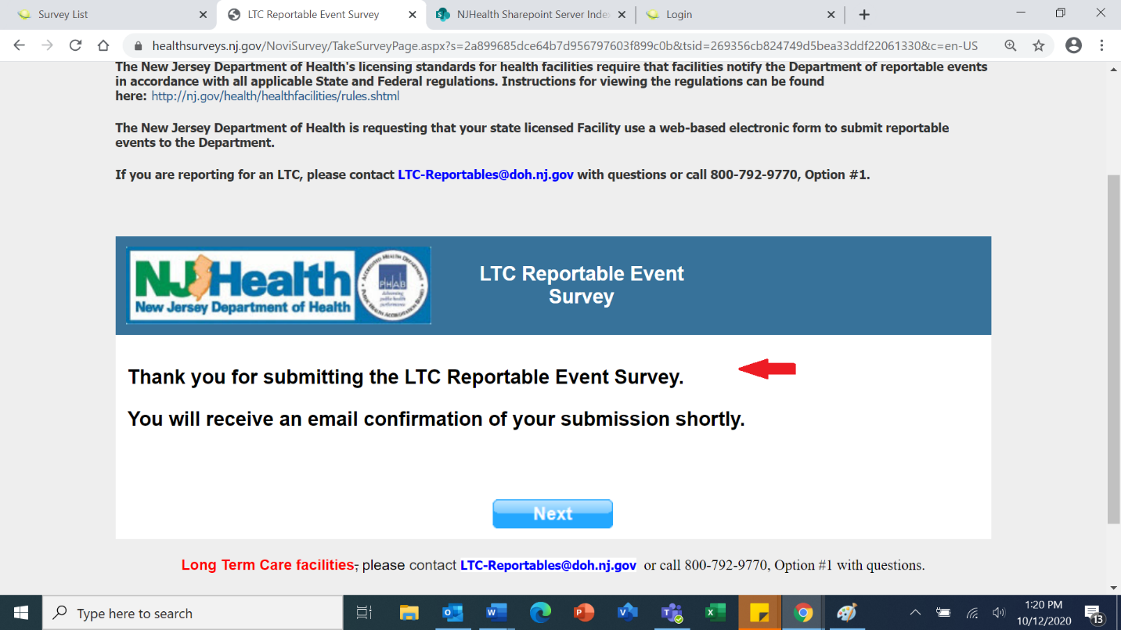

7- You may click the Continue Later button to continue responding to the survey if you had stopped previously without reaching the end of the survey. The below Message will be displayed.

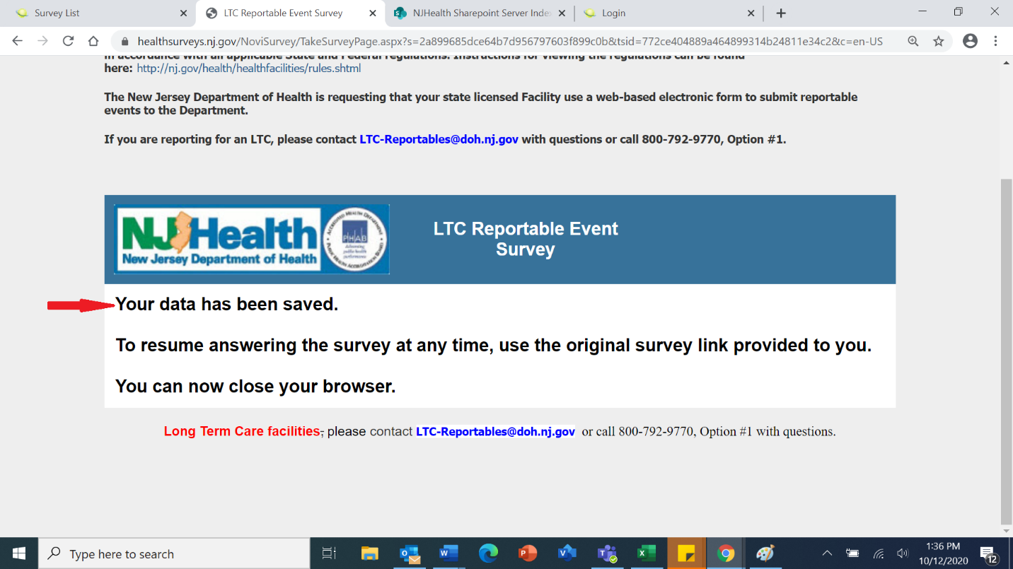

Please contact LTC-Reportables@doh.nj.gov or call 800-792-9770, Option #1 with questions or if you need assistance.

